Project Database
Health Care Management System

Kaltrina Lala

Introduction
Medical clinics require efficient management of patient data, particularly in tracking prescriptions and treatment histories. The Health Care Management System (HCMS) aims to address the growing need in medical clinics for efficient patient data handling and prescription processing. Its primary goal is to streamline the creation, tracking, and reporting of prescriptions to ensure that patients receive accurate and timely medical treatments. By digitizing and automating these processes, the system reduces manual errors, increases accessibility for medical staff, and maintains a comprehensive history of patient treatments—aligning with modern healthcare standards for integrated and secure systems.
The core idea of the project is to build a structured, normalized, and indexed relational database system that stores information related to patients, doctors, medications, and prescriptions. By implementing optimized data models and query operations, the system will improve data consistency, performance, and maintainability.

System Objectives
- Prescription Management: Automate the creation, modification, and tracking of prescriptions with dosage details, frequency, and administration methods.
- Patient-Doctor Workflow: Facilitate seamless interactions between doctors and patients, including appointment scheduling and treatment updates.
- Reporting & Analytics: Generate dynamic reports for doctors and patients, filtered by date ranges, treatment progress, or medication history.
- Scalability & Performance: Optimize database performance through partitioning and indexing to handle growing prescription records efficiently.
-Prescription Management
- Create new prescriptions that include all required medications, their quantities, dosage instructions, and frequency of use.
- Maintain a treatment history and document the expected outcomes of each prescription or treatment.
- Generate reports filtered by specific doctors or patients within a selected time range.

System Scope & User Roles
The HCMS will support two primary user groups with distinct permissions:
1. Doctor Profile
Permissions include:
- View and update personal profile details.
- Manage patient records (e.g., diagnoses, prescriptions).
- Monitor bed occupancy and availability.
- Generate reports on patient treatments, medication adherence, or clinic-wide trends.
- Access real-time medication inventory for emergency preparedness.
2. Patient Profile
Permissions include:
- View personal medical history and prescriptions.
- Request appointments with specific doctors.
- Track treatment updates and generate personal health reports.

Database Design & Optimization
Normalization (3NF Compliance)
The database schema adheres to Third Normal Form (3NF) to eliminate redundancy and ensure data integrity:
- 1NF: All tables contain atomic values (e.g., prescription_medicines uses a composite key for many-to-many relationships).
- 2NF: Non-key attributes fully depend on primary keys (e.g., prescription_date is tied to prescription_id).
- 3NF: Transitive dependencies removed (e.g., patient expenses link directly to services, not intermediary tables).
This normalization ensures efficient data updates, reduces redundancy, and supports consistent data storage across all tables (e.g., patients, doctors, prescriptions, appointments, and medicines).
Partitioning Strategy
The prescription_medicines table is expected to grow rapidly. To maintain performance:
- Horizontal partitioning by month splits the data based on the prescription date (e.g., prescription_date LIKE '2025-04%') reduces query scan volume.
- Ensures faster access for time-bound reports (e.g., "April 2025 prescriptions").
- Reduces the volume of data scanned during queries.
- Improves the performance and scalability of the system, especially for high-frequency operations like reporting and prescription retrieval.
Indexing & Query Optimization
- Indexes on frequently queried columns (med_quantity, prescription_date, patient_id).
- Targeted indexing is applied to frequently queried fields, such as prescription_date (used in time-filtered reports).
These indexes significantly reduce query time, especially for large datasets, from O(n) to approximately O(log n).

Implementation Phases
Phase 1: Requirements & ER Modeling
- Define use cases for doctors, patients, and administrators.
- Develop ER diagrams (provided in documentation) to map relationships (e.g., prescriptions → patients → doctors).
Phase 2: Schema Design & SQL Scripting
- Create tables with constraints (e.g., foreign keys for prescription_p_id → patient_id).
- Implement partitioning and indexing strategies.
Phase 3: Data Population & Query Development
- Populate test data for realistic scenarios.
- Develop 20+ managerial queries, such as:
  - "List all prescriptions for Patient X."
  - "Identify medications below stock threshold."
  - "Generate monthly reports for Doctor Y."
Phase 4: Role-Based Access & Security
- Define views/stored procedures for doctors and patients.
- Restrict direct table access to comply with privacy regulations (e.g., HIPAA).
Access Control and Security
Role-Based Access Control (RBAC)
The system enforces strict access control through role-based views and permissions:
- Doctors can update medical data, manage bed status, and generate reports.
- Patients are restricted to viewing their own data, appointments, and prescription details.
This separation of privileges enhances security and complies with healthcare data privacy standards (e.g., HIPAA or local equivalents). Sensitive fields (like symptoms) are viewable only by authorized users.

Scalability and Future Integration
The system is designed using modular and scalable architecture, enabling:
- Future addition of modules (e.g., lab tests, billing systems).
- Integration with external systems like pharmacies or insurance providers.
- Easy adaptation to growing data without redesigning the schema, thanks to normalization and partitioning strategies.

Research & Validation
The design draws on industry best practices:
- Partitioning improves performance for large datasets (Coronel & Morris, 2019).
- Normalization minimizes update anomalies (Elmasri & Navathe, 2016).
- Role-Based Access Control (RBAC) ensures data security (Ferraiolo et al., 2003).
References
•Coronel, C., & Morris, S. (2019). Database Systems: Design, Implementation, & Management (13th ed.). Cengage.
•Elmasri, R., & Navathe, S. B. (2016). Fundamentals of Database Systems (7th ed.). Pearson.
•Ferraiolo, D. F., Kuhn, D. R., & Chandramouli, R. (2003). Role-Based Access Control. Artech House.
•Garcia-Molina, H., Ullman, J. D., & Widom, J. (2008). Database Systems: The Complete Book (2nd ed.). Prentice Hall.

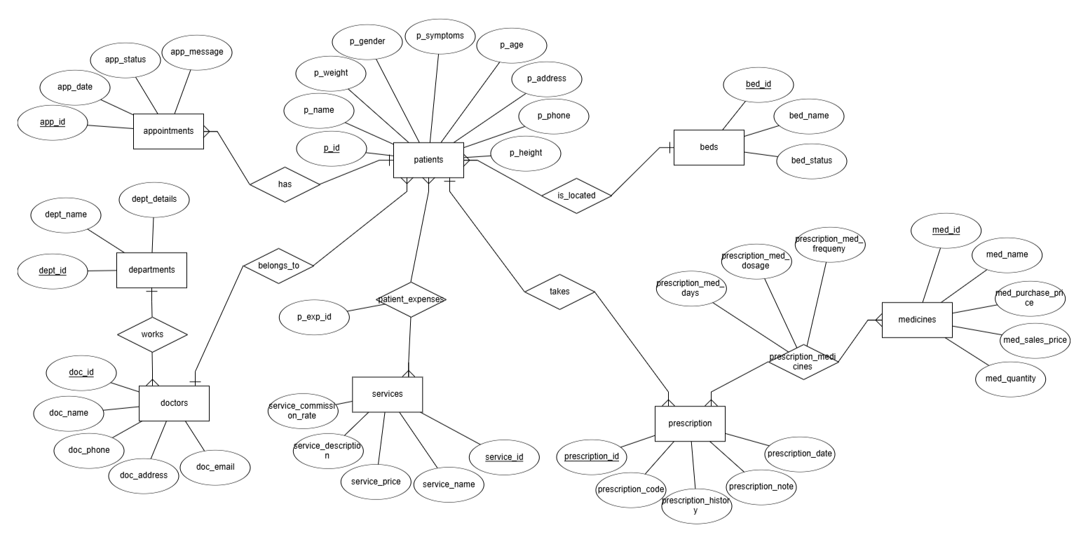
ER-Diagram

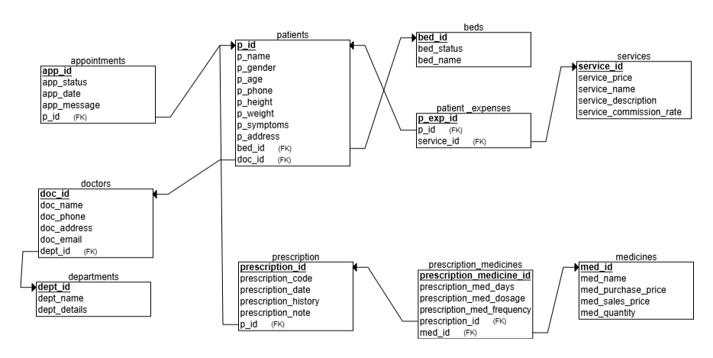
Relational-Schema

Relationships Between Entities

🟨 patients — 🟥 doctors
- A patient has 1 doctor
- A doctor can have many patients
Relationship: 1 : N (One-to-many)

🟨 patients — 🟥 beds
- Each patient has 1 bed
- A bed can be used by many patients (at different times)
Relationship: 1 : N (One-to-many)

🟨 doctors — 🟥 departments
- Each doctor belongs to 1 department
- A department has many doctors
Relationship: 1 : N (One-to-many)

🟨 appointments — 🟥 patients
- An appointment belongs to 1 patient
- A patient can have many appointments
Relationship: 1 : N (One-to-many)

🟨 prescriptions — 🟥 patients
- Each prescription belongs to 1 patient
- A patient can have many prescriptions
Relationship: 1 : N (One-to-many)

🟨 prescription_medicines — 🟥 prescriptions & 🟥 medicines
This is a linking table for a many-to-many relationship:
- A prescription can include many medicines
- A medicine can appear in many prescriptions
Relationship: prescriptions — prescription_medicines — medicines
So: M:N, implemented as two 1:N relationships using a linking table.

🟨 patient_expenses — 🟥 patients & 🟥 services
This is also a linking table for a many-to-many relationship:
- A patient can receive many services
- A service can be used by many patients
Relationship: patients — patient_expenses — services
So: M:N, implemented using two 1:N relationships through a linking table.

Database Creation(SQL CODE)

CREATE TABLE appointments (
app_id INTEGER PRIMARY KEY AUTOINCREMENT CHECK (app_id > 0),
app_date TEXT NOT NULL,
app_status TEXT NOT NULL,
app_message TEXT NOT NULL,
patient_id INTEGER NOT NULL,
FOREIGN KEY (patient_id) REFERENCES patients(p_id)
);

CREATE TABLE beds (
bed_id INTEGER PRIMARY KEY AUTOINCREMENT CHECK (bed_id > 0),
bed_name TEXT NOT NULL,
bed_status TEXT NOT NULL
);

CREATE TABLE departments (
dept_id INTEGER PRIMARY KEY AUTOINCREMENT CHECK (dept_id > 0),
dept_name TEXT NOT NULL,
dept_details TEXT NOT NULL
);

CREATE TABLE doctors (
doc_id INTEGER PRIMARY KEY AUTOINCREMENT CHECK (doc_id > 0),
doc_name TEXT NOT NULL,
doc_phone TEXT NOT NULL,
doc_address TEXT NOT NULL,
doc_email TEXT NOT NULL,
doc_dept_id INTEGER NOT NULL CHECK (doc_dept_id > 0),
FOREIGN KEY (doc_dept_id) REFERENCES departments(dept_id)
);

CREATE TABLE patients (
p_id INTEGER PRIMARY KEY AUTOINCREMENT CHECK (p_id > 0),
p_name TEXT NOT NULL,
p_gender TEXT NOT NULL,
p_age INTEGER NOT NULL,
p_phone TEXT NOT NULL,
p_height TEXT NOT NULL,
p_weight TEXT NOT NULL,
p_symptoms TEXT NOT NULL,
p_address TEXT NOT NULL,
p_doc_id INTEGER NOT NULL CHECK (p_doc_id > 0),
p_bed_id INTEGER NOT NULL CHECK (p_bed_id > 0),
FOREIGN KEY (p_doc_id) REFERENCES doctors(doc_id),
FOREIGN KEY (p_bed_id) REFERENCES beds(bed_id)
);

CREATE TABLE medicines (
med_id INTEGER PRIMARY KEY AUTOINCREMENT CHECK (med_id > 0),
med_name TEXT NOT NULL,
med_purchase_price INTEGER NOT NULL,
med_sales_price INTEGER NOT NULL,
med_quantity INTEGER NOT NULL
);

CREATE TABLE patient_expenses (
p_exp_id INTEGER PRIMARY KEY AUTOINCREMENT CHECK (p_exp_id > 0),
p_service_id INTEGER NOT NULL CHECK (p_service_id > 0),
patient_id INTEGER NOT NULL,
FOREIGN KEY (p_service_id) REFERENCES services(service_id),
FOREIGN KEY (patient_id) REFERENCES patients(p_id)
);

CREATE TABLE prescriptions (
prescription_id INTEGER PRIMARY KEY AUTOINCREMENT CHECK (prescription_id > 0),
prescription_code TEXT NOT NULL,
prescription_p_id INTEGER NOT NULL CHECK (prescription_p_id > 0),
prescription_history TEXT NOT NULL,
prescription_note TEXT NOT NULL,
prescription_date TEXT NOT NULL,
FOREIGN KEY (prescription_p_id) REFERENCES patients(p_id)
);

CREATE TABLE prescription_medicines (
prescription_id INTEGER NOT NULL CHECK (prescription_id > 0),
prescription_medicine_id INTEGER NOT NULL CHECK (prescription_medicine_id > 0),
prescription_med_dosage TEXT NOT NULL,
prescription_med_frequency TEXT NOT NULL,
prescription_med_days TEXT NOT NULL,
PRIMARY KEY (prescription_id, prescription_medicine_id),
FOREIGN KEY (prescription_id) REFERENCES prescriptions(prescription_id),
FOREIGN KEY (prescription_medicine_id) REFERENCES medicines(med_id)
);

CREATE TABLE services (
service_id INTEGER PRIMARY KEY AUTOINCREMENT CHECK (service_id > 0),
service_name TEXT NOT NULL,
service_price INTEGER NOT NULL,
service_description TEXT NOT NULL,
service_commission_rate INTEGER NOT NULL
);

Managerial Queries
Managerial queries are SQL queries that help managers or decision-makers gain insights from a database for planning, monitoring, and decision-making. These queries often involve summarizing, analyzing, and reporting data, rather than focusing on individual records like operational queries. Below are several different queries presented to retrieve various types of data.

-- QUERY 1: List all patients
SELECT * FROM patients;
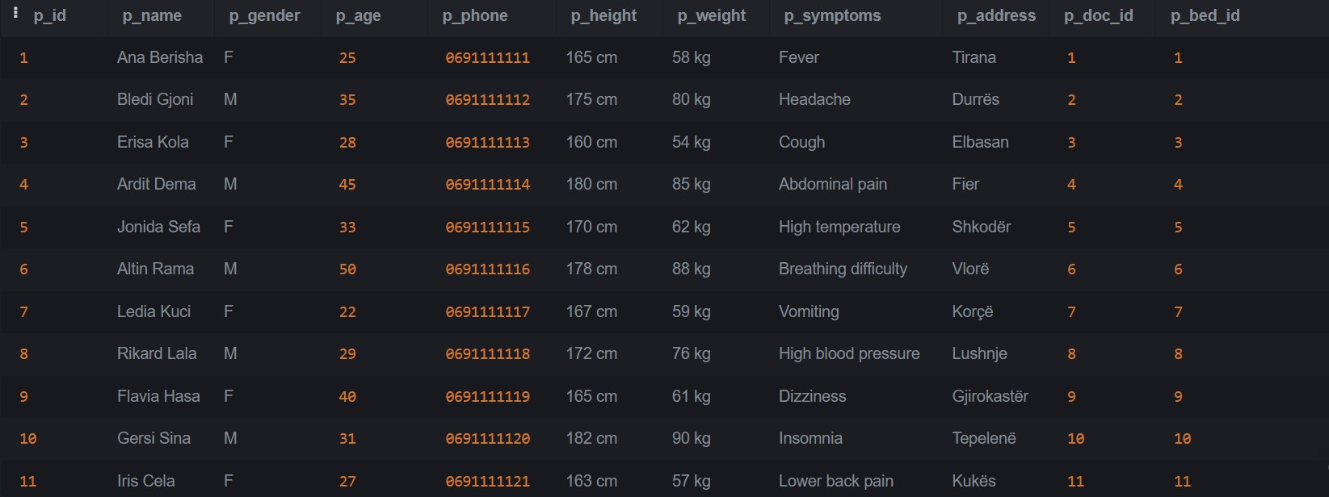

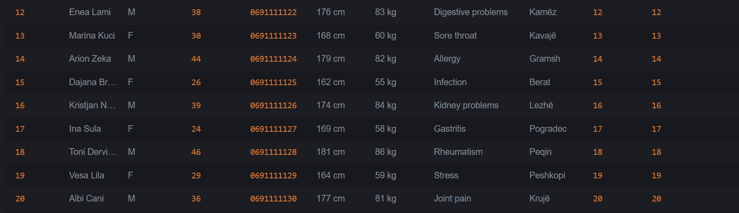

-- QUERY 2: List all departments
SELECT * FROM departments;
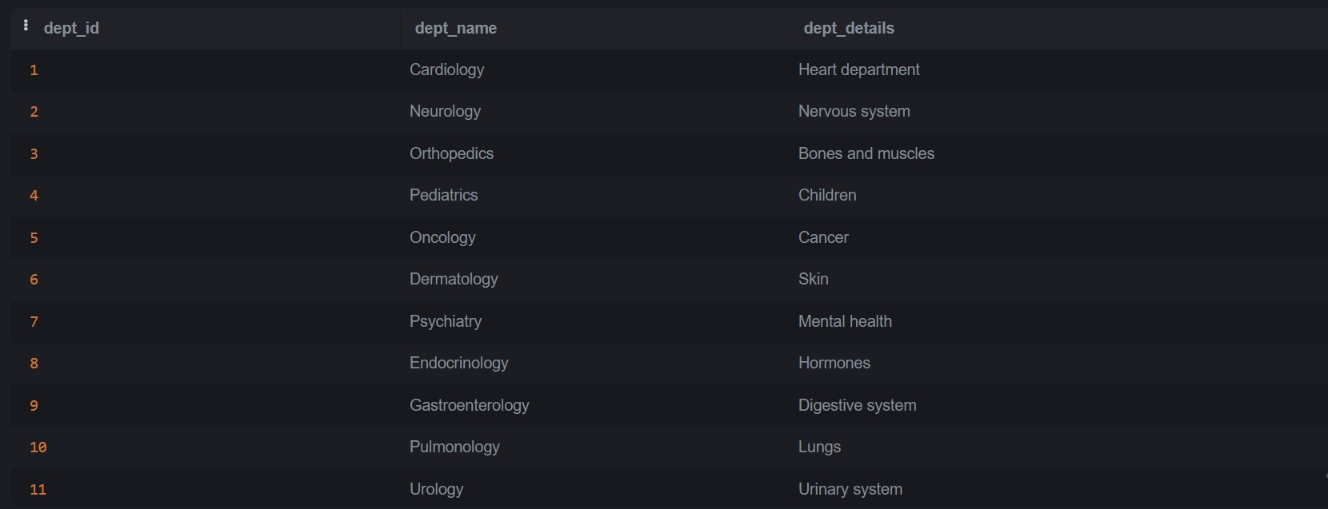

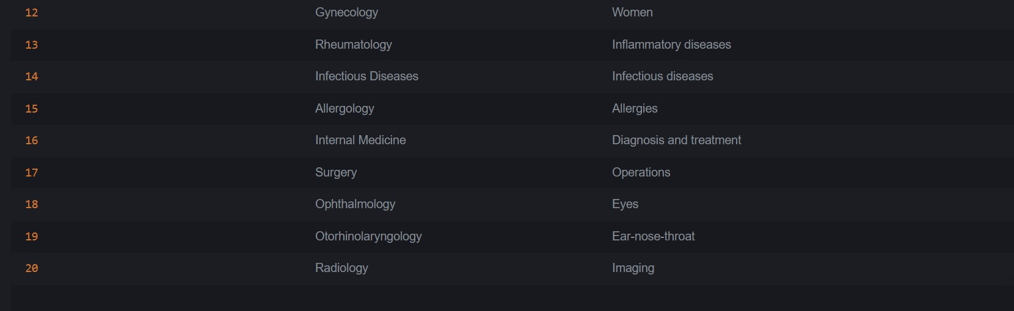

-- QUERY 3: Patients older than 30
SELECT p_name, p_age FROM patients WHERE p_age > 30;


-- QUERY 4: Medicines with low stock
SELECT med_name, med_quantity FROM medicines WHERE med_quantity < 100;
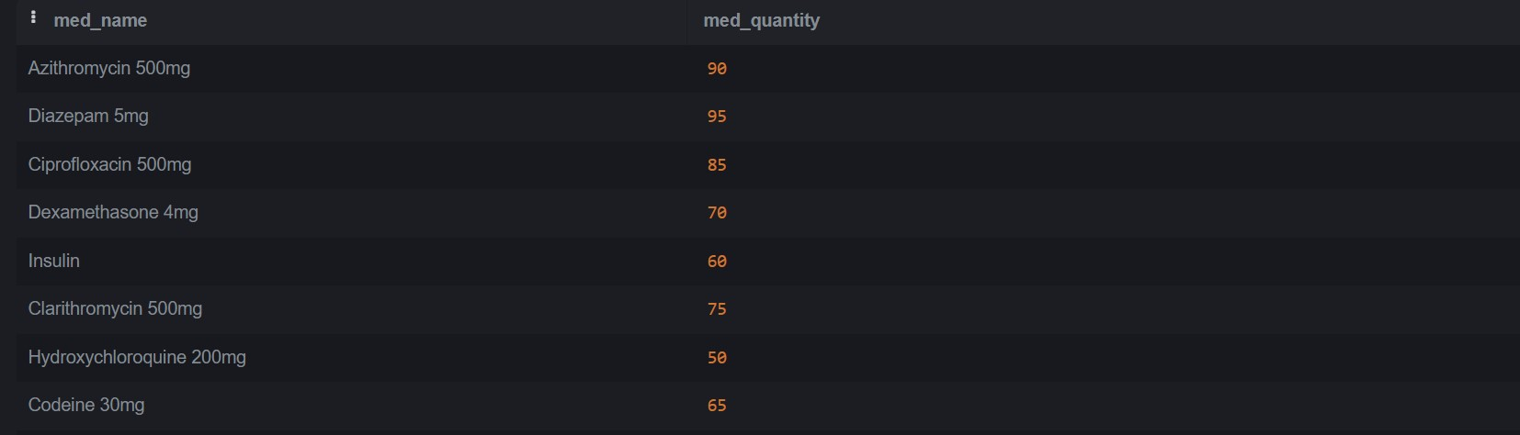

-- QUERY 5: Planned appointments for pacients
SELECT *
FROM appointments, patients
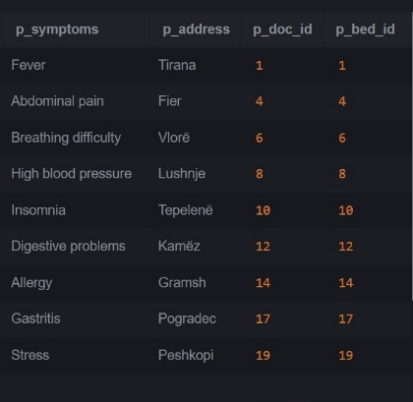
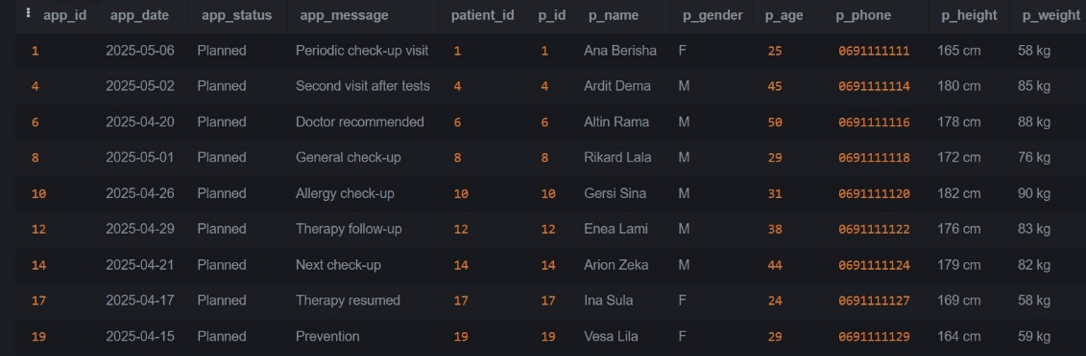
WHERE patient_id=p_id AND app_status = 'Planned';

-- QUERY 6: Prescriptions for a specific patient
SELECT p.*
FROM prescriptions p
JOIN patients pt ON p.prescription_p_id = pt.p_id
WHERE pt.p_name LIKE 'Ana%';

-- QUERY 7: Doctors in a specific department
SELECT doc_name FROM doctors WHERE doc_dept_id = (SELECT dept_id FROM departments WHERE dept_name = 'Neurology');


-- QUERY 8: Services priced above 1000
SELECT service_name, service_price FROM services WHERE service_price > 1000;
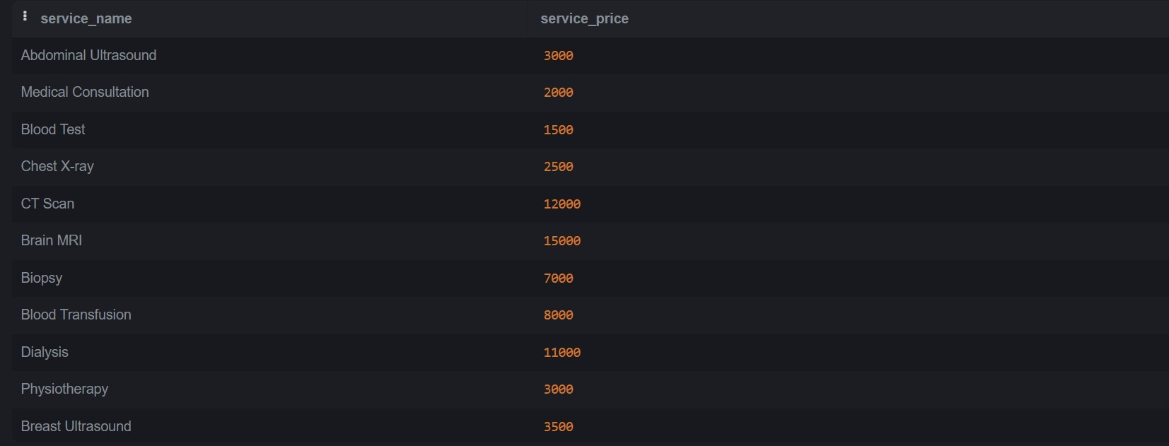

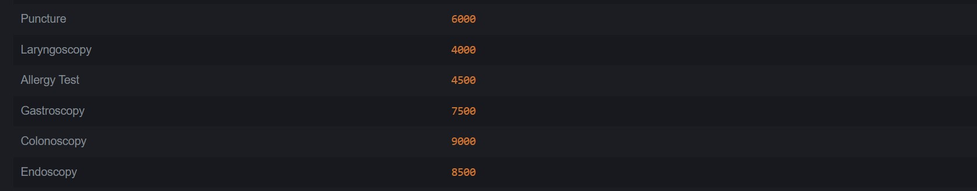

-- QUERY 9: Medicines with high profit margin
SELECT med_name, med_sales_price - med_purchase_price AS profit FROM medicines WHERE (med_sales_price - med_purchase_price) > 5;
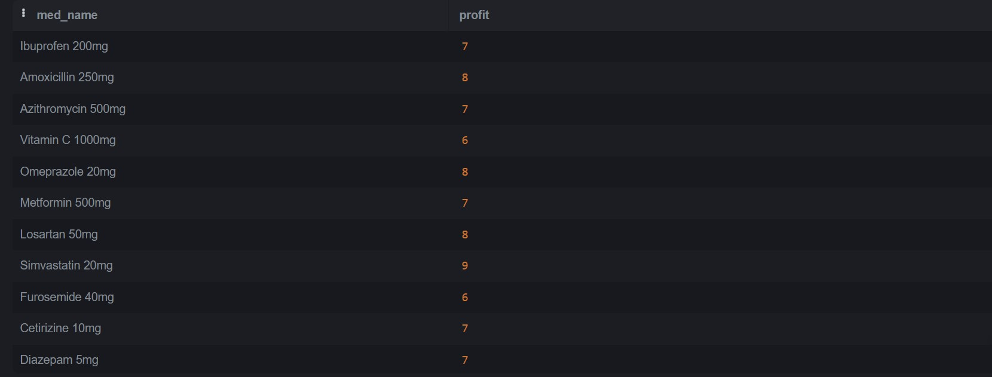

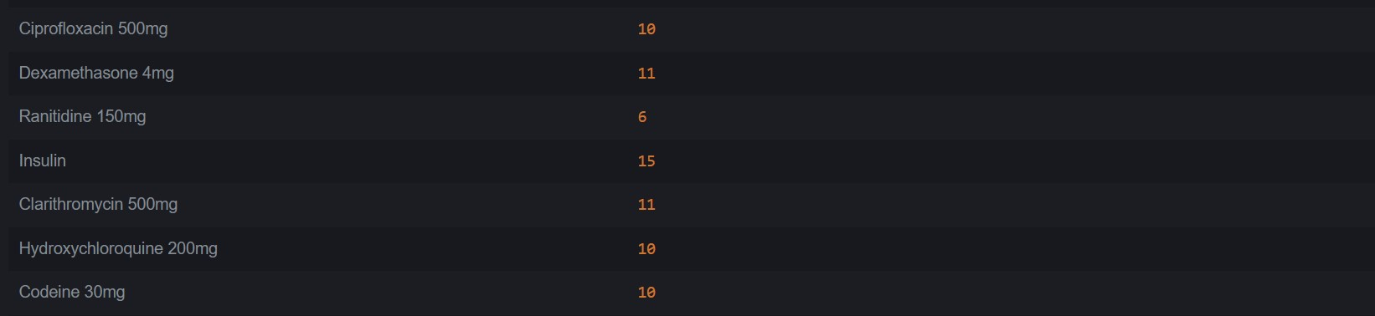

-- QUERY 10: Patients and their respective doctors
SELECT p.p_name, d.doc_name FROM patients p
JOIN doctors d ON p.p_doc_id = d.doc_id;




-- QUERY 11: Prescriptions with medicine and patient names
SELECT pr.prescription_code, m.med_name, pa.p_name FROM prescriptions pr
JOIN prescription_medicines pm ON pr.prescription_id = pm.prescription_id
JOIN medicines m ON pm.prescription_medicine_id = m.med_id
JOIN patients pa ON pr.prescription_p_id = pa.p_id;
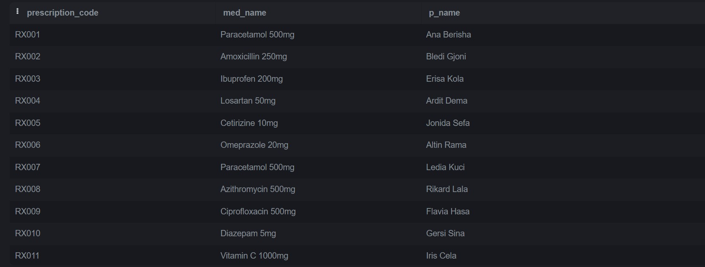



-- QUERY 12: Patients with more one registered service
SELECT p.p_name, COUNT(*) AS total_services FROM patient_expenses pe
JOIN patients p ON pe.patient_id = p.p_id
GROUP BY p.p_name HAVING COUNT(*) = 1;
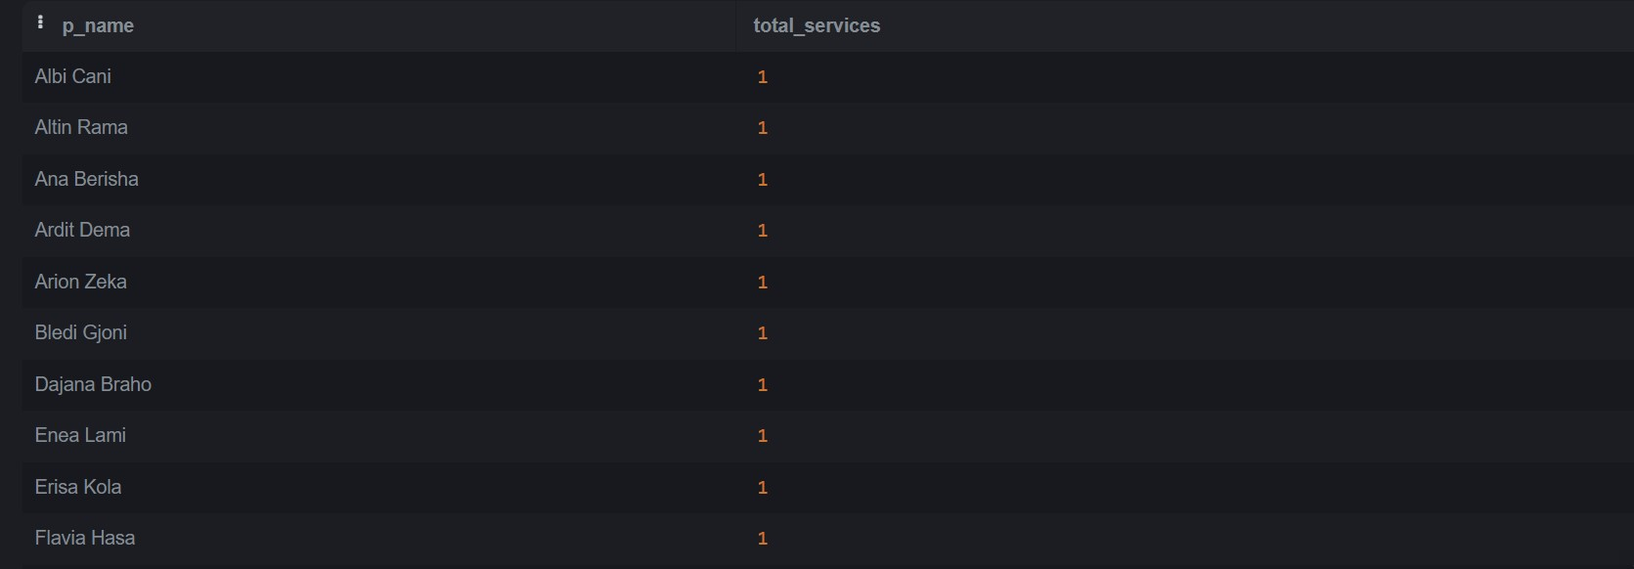



-- QUERY 13: Number of patients per doctor
SELECT d.doc_name, COUNT(p.p_id) AS num_patients FROM doctors d
JOIN patients p ON p.p_doc_id = d.doc_id
GROUP BY d.doc_name;
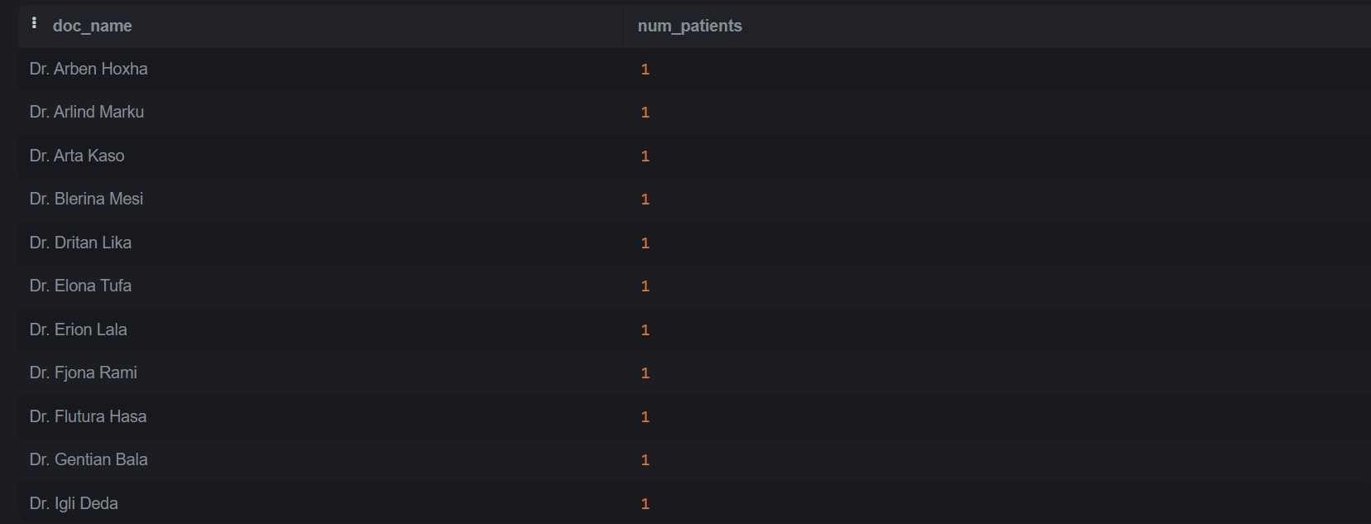



-- QUERY 14: Prescriptions issued in April 2025
SELECT * FROM prescriptions WHERE prescription_date LIKE '2025-04%';

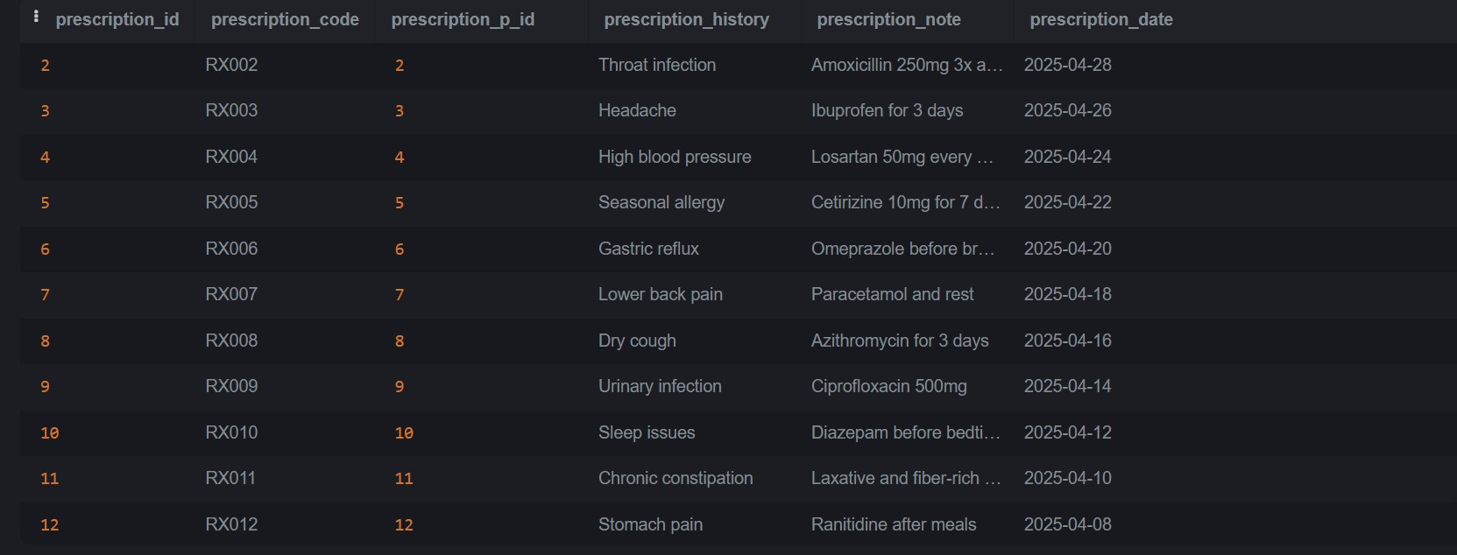



-- QUERY 15: Change the status of a bed
UPDATE beds SET bed_status = 'Occupied' WHERE bed_name = 'Bed C1';
Before update
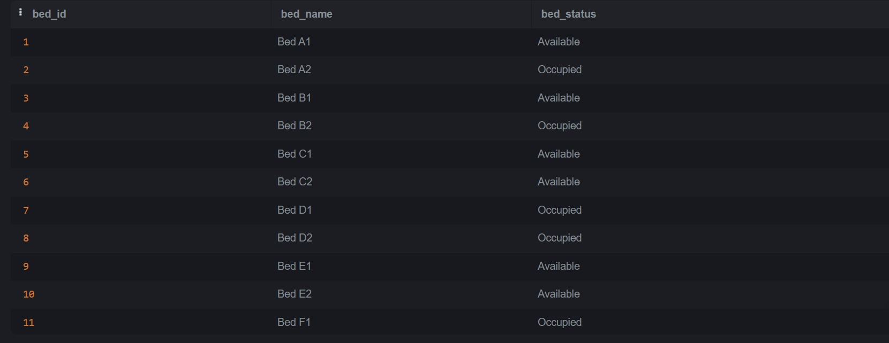

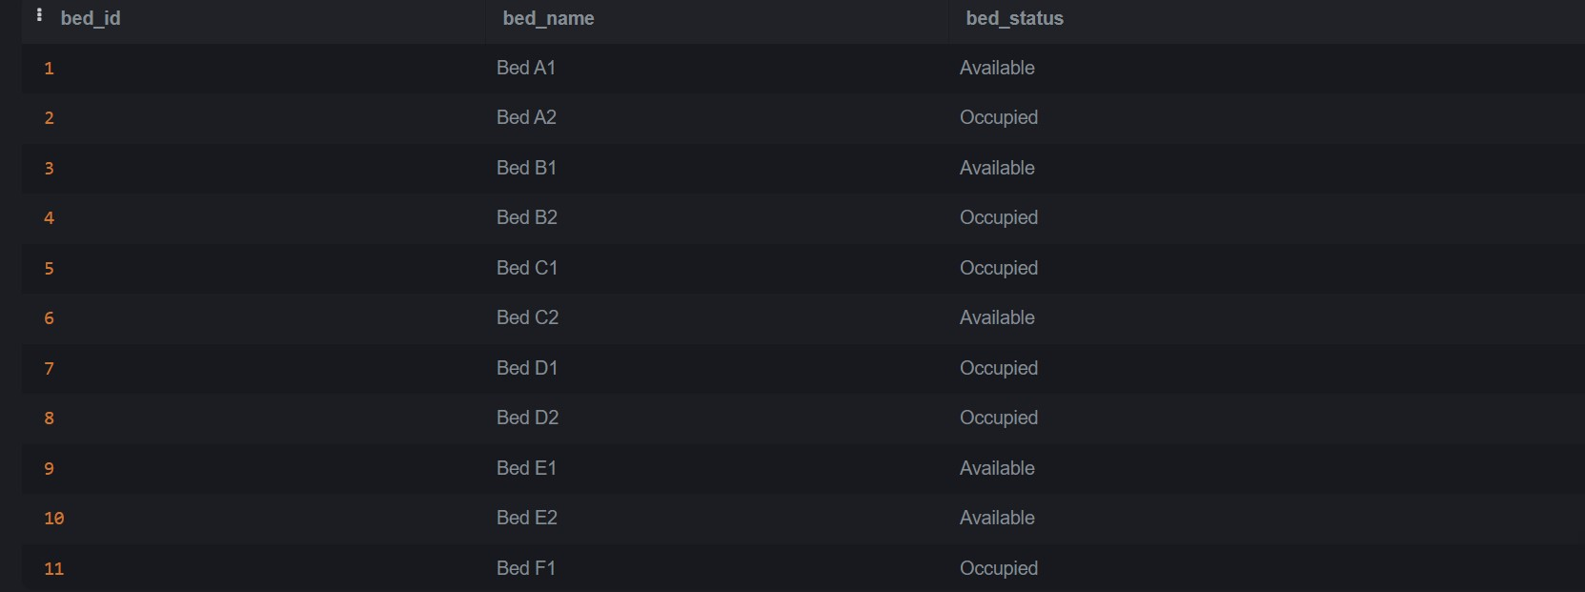
After update

-- QUERY 16: Update the price of a service
UPDATE services SET service_price = 1800 WHERE service_name = 'Chest X-ray';
Before update
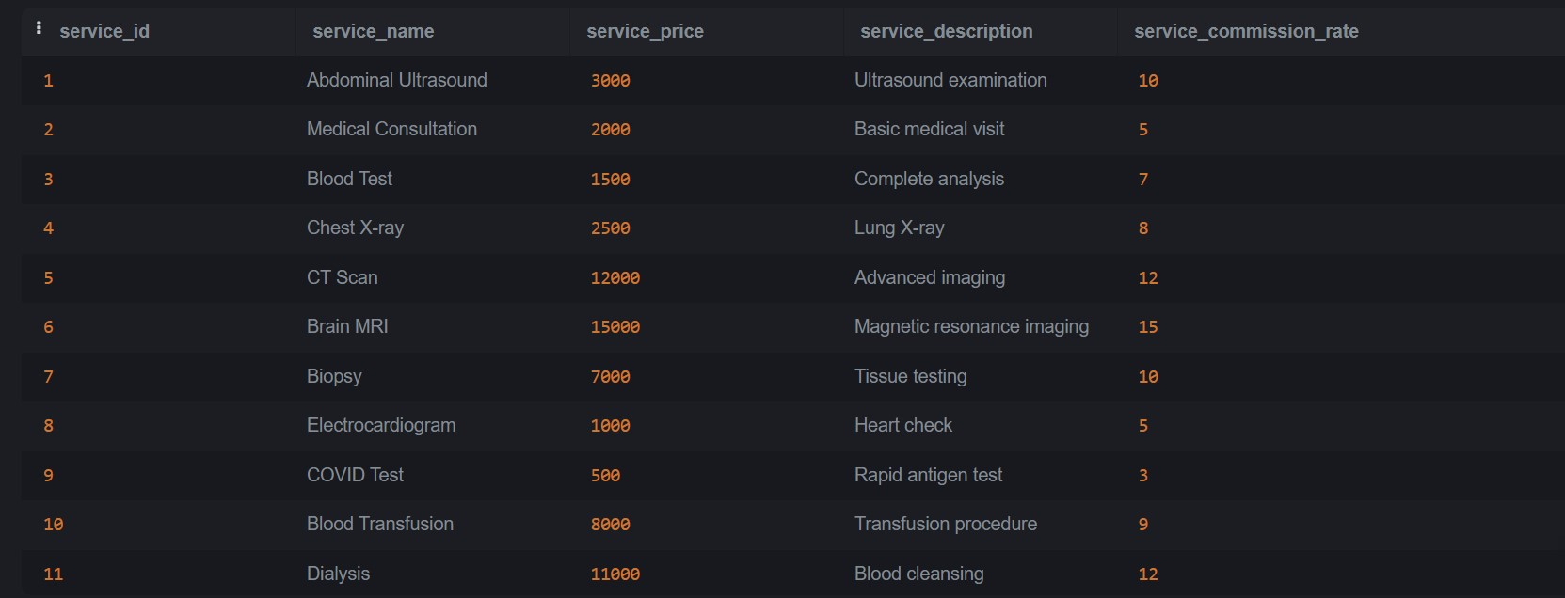

After update
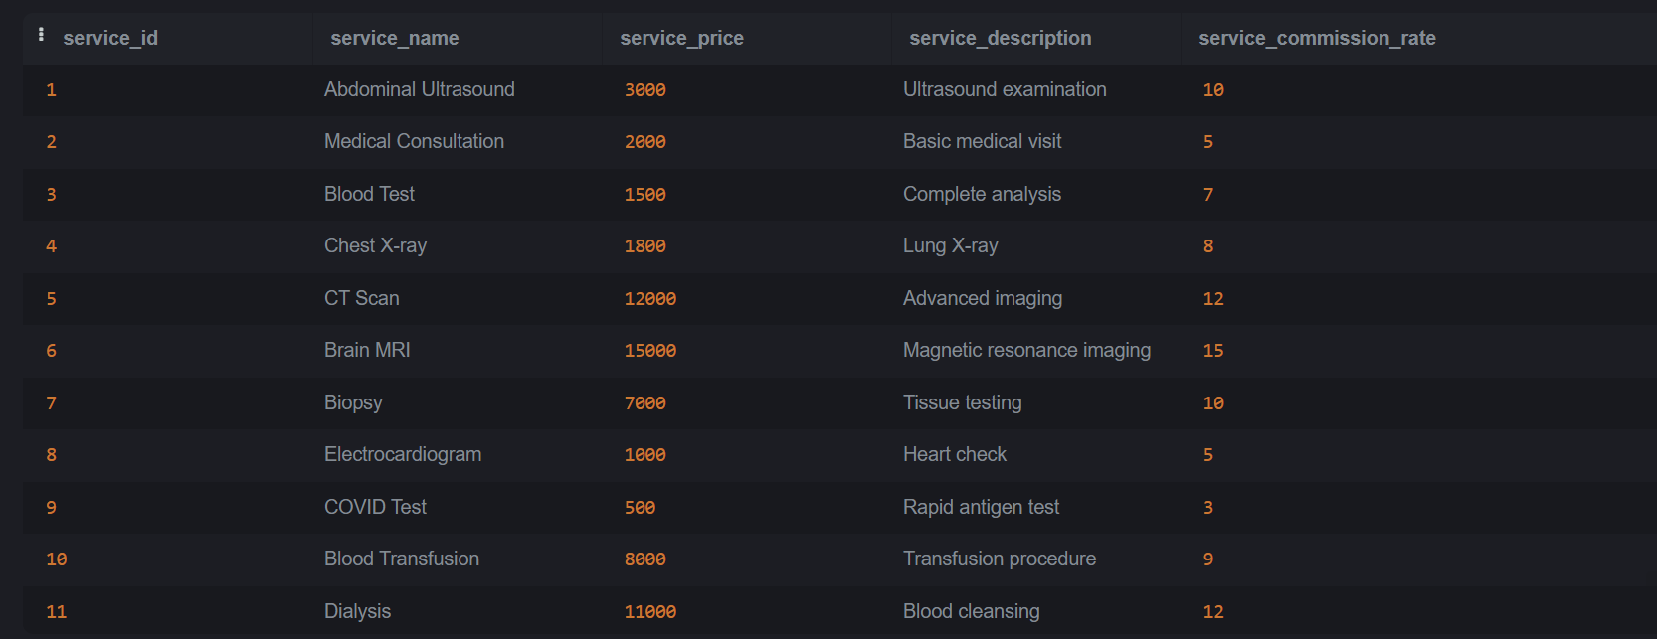

-- QUERY 17: Delete a specific appointment
DELETE FROM appointments WHERE app_message = 'Periodic check-up visit';
Before delete
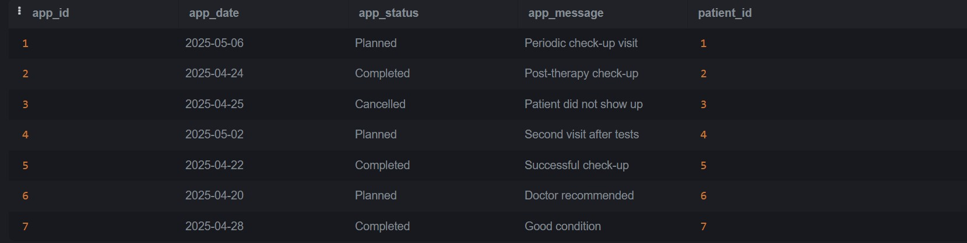

After delete

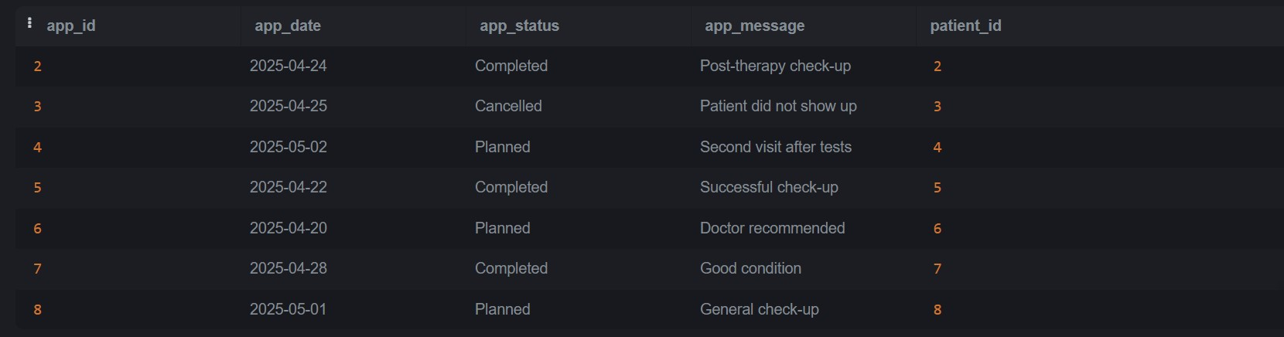

-- QUERY 18: Patients treated by a doctor his surname finished with Kola
SELECT p.p_name, d.doc_name FROM patients p
JOIN doctors d ON p.p_doc_id = d.doc_id
WHERE d.doc_name LIKE '%Kola';

-- QUERY 19: Beds assigned to female patients
SELECT b.bed_name, p.p_name FROM beds b
JOIN patients p ON b.bed_id = p.p_bed_id
WHERE p.p_gender = 'F';
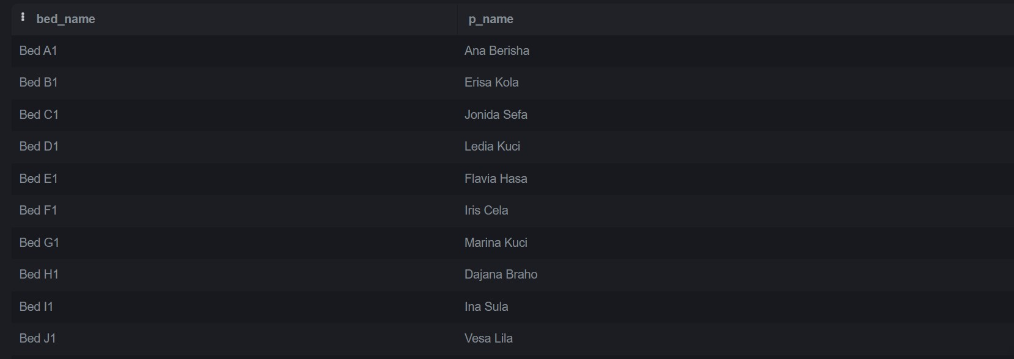

-- QUERY 20: Appointments for patients with symptom 'Cough'
SELECT a.app_date, a.app_status, p.p_name FROM appointments a
JOIN patients p ON a.patient_id = p.p_id
WHERE p.p_symptoms = 'Cough';
Conclusion

The Health Care Management System we created demonstrates how effective database design can solve practical problems in the healthcare sector. Our system manages essential components like patients, doctors, appointments, prescriptions, and medicine stock with efficiency and accuracy. We followed a clear development process: starting with requirements analysis, designing the ER diagram, applying normalization up to Third Normal Form (3NF), and implementing the database with real-world SQL queries. We also introduced horizontal partitioning in large tables to boost performance as the system scales. The platform provides tailored features for both doctors and patients — improving communication, resource usage, and access to vital medical information. Through this project, we’ve applied theoretical concepts in a meaningful way and built a solution that offers both academic and practical value for modern healthcare environments.

